**ELECTRIC VEHICLE MARKET SEGEMNTATION IN INDIA**

Saif Jawed

GitHub Link: <https://github.com/saif1210/Feynn_Labs_Internship>

The electric vehicle (EV) market in India is growing rapidly. In 2022, the market size was valued at USD 2.2 billion and is expected to reach USD 152.21 billion by 2030, growing at a CAGR of 94.4%. The growth of the EV market in India is being driven by a number of factors, including:

* Government incentives: The Indian government has introduced a number of incentives to promote the adoption of EVs, including tax breaks, subsidies, and exemptions from registration fees.
* Rising fuel prices: The rising cost of fuel is making EVs more attractive to consumers.
* Increasing environmental awareness: There is growing awareness among consumers about the environmental benefits of EVs.
* Improved technology: The technology of EVs has improved significantly in recent years, making them more affordable and efficient.

The EV market in India is still in its early stages, but it is growing rapidly. The two-wheeler segment is the largest segment of the EV market in India, followed by the three-wheeler segment. The passenger car segment is also growing rapidly, and is expected to become the largest segment of the market by 2030.

The growth of the EV market in India is creating new opportunities for businesses. There is a growing demand for EV components, such as batteries, motors, and chargers. There is also a growing demand for EV services, such as charging infrastructure and fleet management. The government has set a target to achieve 30 percent electrification of the country's vehicle fleet by 2030.

Here are some of the key trends that are shaping the EV market in India:

* The growth of the two-wheeler and three-wheeler segments: These segments are expected to continue to grow rapidly in the coming years, as they are the most affordable and accessible forms of EVs.
* The increasing popularity of passenger cars: The passenger car segment is growing rapidly, as consumers are becoming more aware of the environmental benefits of EVs.
* The growth of the commercial vehicle segment: The commercial vehicle segment is also growing rapidly, as businesses are looking to reduce their operating costs by switching to EVs.
* The development of charging infrastructure: The development of charging infrastructure is essential for the growth of the EV market in India. The government is taking steps to develop charging infrastructure, and private companies are also investing in this area.

The growth of the EV component manufacturing industry: The growth of the EV market in India is creating new opportunities for businesses in the EV component manufacturing industry.

The EV market in India is a rapidly growing market with significant potential. The government is taking steps to promote the adoption of EVs, and the private sector is also investing in this area. The growth of the EV market in India is creating new opportunities for businesses in a variety of sectors.

# Problem Statement

An EV startup is developing electric vehicles (EVs) and are trying to decide which vehicle/customer space to target. The Indian EV market is growing rapidly, but it is still in its early stages. There are a number of different segments in the market, each with its own unique characteristics. We need to analyze the market and identify the segments that are most likely to adopt EVs. We also need to develop a feasible strategy to enter the market and compete in these segments.

The Indian EV market can be segmented based on the following criteria:

* **Vehicle type**: The EV market can be segmented into two-wheelers, three-wheelers, passenger cars, and commercial vehicles. Two-wheelers are the most popular type of EV in India, followed by three-wheelers. Passenger cars and commercial vehicles are still in the early stages of development.
* **Customer**: The EV market can also be segmented by customer type. Customer behavioural data can be used to perform market segmentation.

# Data Sources

To perform the market segmentation for the EV market we will analyze three datasets with the following sources:

* Charging Stations in India: [https://www.kaggle.com/datasets/saketpradhan/electricvehicle-charging-stations-in-india](https://www.kaggle.com/datasets/saketpradhan/electric-vehicle-charging-stations-in-india)
* EV Population Data of USA: [https://catalog.data.gov/dataset/electric-vehiclepopulation-data](https://catalog.data.gov/dataset/electric-vehicle-population-data)
* Indian Automobile Buying Behaviour: [https://www.kaggle.com/datasets/karivedha/indian-consumers-cars-purchasingbehaviour](https://www.kaggle.com/datasets/karivedha/indian-consumers-cars-purchasing-behaviour)

# Analysis of Charging Stations in India

The columns in the dataset are:

* **name**: The name of the charging station
* **state**: The state where the charging station is located
* **city**: The city where the charging station is located
* **address**: The address of the charging station
* **lattitude**: The latitude of the charging station
* **longitude**: The longitude of the charging station

**type**: The type of charging station (slow, fast, or ultra-fast)

## Data Preprocessing

The following data pre-processing steps using pandas library were done on the dataset:

1. The data had 205 duplicate entries which were dropped from the dataset.
2. Rows with missing values were removed.
3. A new variable **charging_speed** was created using the **type** variable.
4. There was some bad data in the **latitude** and **longitude** variables which were cleaned.
5. There were some duplicate and incorrect **state** and **city** names which were cleaned.

## Inferences from the EDA

* The distribution of charging stations in India is uneven, with the majority of stations located in the states of Maharashtra, Delhi, and Tamil Nadu.
* The city with the highest number of charging stations is New Delhi, followed by Bangalore and Chennai. These cities are all major metropolitan areas with a high demand for electric vehicles.
* Most of the charging stations in India provide slow charging for EVs, while there are very few ultra-fast charging stations. This is likely due to the high cost of ultra-fast chargers.
* Karnataka has the highest number of fast charging stations in India, followed by Maharashtra and Telangana. Bangalore has the highest number of fast charging stations in India.
* Tamil Nadu and Maharashtra have the highest number of ultra-fast charging stations in India, followed by Telangana and Karnataka. Hyderabad has the highest number of ultra-fast charging stations in India.

These observations suggest that the demand for electric vehicles is highest in the major metropolitan areas of India. The government of India should focus on developing charging infrastructure in these areas to support the growth of the electric vehicle market.

# Analysis of EV Population Data

The dataset includes the following columns:

* **VIN (1-10)**: The vehicle identification number (VIN) of the electric vehicle.
* **County**: The county where the electric vehicle is registered.
* **City**: The city where the electric vehicle is registered.
* **State**: The state where the electric vehicle is registered.
* **ZIP Code**: The ZIP code where the electric vehicle is registered.
* **Model Year**: The model year of the electric vehicle.
* **Make**: The make of the electric vehicle.
* **Model**: The model of the electric vehicle.
* **Electric Vehicle Type**: The type of electric vehicle, such as battery electric vehicle (BEV) or plug-in hybrid electric vehicle (PHEV).
* **Clean Alternative Fuel Vehicle (CAFV) Eligibility**: Whether the electric vehicle is eligible for Clean Alternative Fuel Vehicle (CAFV) incentives.

**Electric Range**: The electric range of the electric vehicle in miles.

* **Base MSRP**: The base manufacturer's suggested retail price (MSRP) of the electric vehicle in US dollars.
* **Legislative District**: The legislative district where the electric vehicle is registered.
* **DOL Vehicle ID**: The vehicle identification number assigned by the Department of Licensing (DOL) of the state of Washington.
* **Vehicle Location**: The location of the electric vehicle, represented as a point in geographic coordinates.

## Data Preprocessing

The following data pre-processing steps using pandas library were done on the dataset:

1. Rows with missing values were removed.

## Inferences from the EDA

* The electric vehicle (EV) market in the United States has seen significant growth in recent years, with battery electric vehicles (BEVs) accounting for the majority of EVs sold.
* The number of EVs made in the US has increased exponentially over the past 13 years, with BEVs leading the way. PHEVs have also seen growth, but not as drastic as BEVs.
* Tesla is the leading manufacturer of EVs in the US, accounting for nearly half of all EVs sold since 1997.
* More than 60,000 EVs are eligible for clean alternative fuel (CAF) incentives, while another 60,000 have not yet been researched to determine eligibility.
* Most of the electric vehicles have an electric range that is clustered between 20 to 40 miles and 200 to 250 miles. PHEVs, in general, have a lower range than BEVs.

These observations suggest that the EV market in the US is growing rapidly, with BEVs leading the way. Tesla is the dominant manufacturer of EVs in the US, and a significant number of EVs are eligible for CAF incentives. However, there is still a lack of data on the electric range of many EVs.

# Analysis of Indian Automobile Buying Behaviour Data

The dataset includes the following columns:

* **Age**: The age of the buyer.
* **Profession**: The occupation of the buyer.
* **Marital Status**: The marital status of the buyer.
* **Education**: The highest level of education of the buyer.
* **No of Dependents**: The number of dependents of the buyer.
* **Personal loan**: Whether the buyer has a personal loan.
* **House Loan**: Whether the buyer has a house loan.
* **Wife Working**: Whether the wife of the buyer is working.
* **Salary**: The salary of the buyer.
* **Wife Salary**: The salary of the wife of the buyer.

**Total Salary**: The combined salary of the buyer and wife.

* **Make**: The make of the automobile purchased.
* **Price**: The price of the automobile purchased.

## Data Preprocessing

The following data pre-processing steps using pandas library were done on the dataset:

1. The Wife Working variable had one extra category with only one data point. This category was merged with the Yes category.

## Inferences from the EDA

* The salary of the customers is grouped around 1000000 and 2500000 Indian rupees. This suggests that the majority of the customers in the dataset are from the uppermiddle class or upper class.
* Wife's salary for most of the customers is zero. For those whose wife is working, the salary is between 500000 and 1500000 Indian rupees.
* The total household salary of the customer is between 1000000 and 3000000 Indian rupees. This suggests that the majority of the customers in the dataset have a comfortable financial situation.
* The price of the cars purchased by the customers range between 500000 and 2000000 Indian rupees. This suggests that the majority of the customers in the dataset have purchased mid-range cars.
* Around 65% of the customers are salaried while 35% have their own business. This suggests that the majority of the customers in the dataset are employed professionals.
* Most of the customers in the dataset are married. This suggests that the majority of the customers in the dataset are in a stable family situation.
* Around 55% of the customers hold a post-graduate degree while 35% have a graduate degree. This suggests that the majority of the customers in the dataset are welleducated.
* Most of the customers have 3 and 2 dependents. This suggests that the majority of the customers in the dataset have young families.
* Around 68% of the customers do not have a personal loan. This suggests that the majority of the customers in the dataset are able to afford the cars they have purchased without taking out a loan.
* Around 61% of the customers do not have a house loan. This suggests that the majority of the customers in the dataset are able to afford to buy a house without taking out a loan.
* Around 52% of the customer's wives are working. This suggests that the majority of the wives of the customers in the dataset are employed.
* Most of the customers have purchased SUV and Baleno followed by Creata. Very few customers have bought Luxury. This suggests that the majority of the customers in the dataset are interested in practical and fuel-efficient cars.

# Market Segmentation

We will perform the EV Market Segmentation on the Indian Automobile Buying Behaviour dataset.

## Data Preprocessing

The following data pre-processing steps using pandas and sklearn libraries were done on the segmentation dataset:

1. The categorical variables were one-hot encoded using the pd.get_dummies method.
2. The continuous variables were scaled using MinMaxScaler so that their values lie between 0 and 1.

## KMeans Clustering

Here we use the K-means clustering algorithm to segment the car buyers into different groups. The K-means algorithm is a simple and efficient algorithm that can be used to cluster data points into a predefined number of groups.

The K-means algorithm works by iteratively assigning data points to the cluster with the closest mean. The algorithm then recomputes the means of the clusters and repeats the process until the clusters no longer change.

The K-means algorithm is able to find patterns in data that are not easily visible to the naked eye. The algorithm was able to identify the similarities and differences between different clusters, which allowed me to better understand the different types of car buyers.

### Elbow Plot

To determine optimum number of clusters, Elbow Plot can be used. In this plot, the number of clusters are on the X-axis and the corresponding within-cluster sum of squares (WSS) are on the Y-axis.

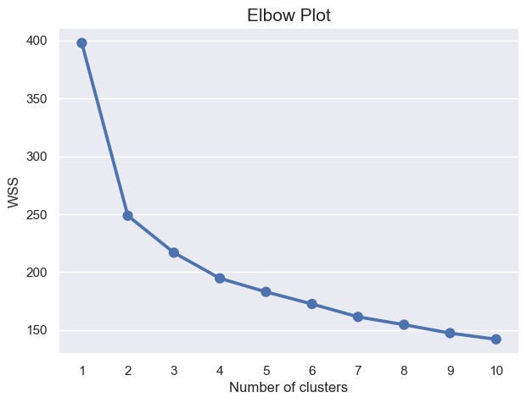

*Figure 1: Elbow Plot*

From the above plot we see that, the drop in WSS for clusters 1 to 2 is very large. But, the drop from clusters 2 to 3 is not significant. After cluster 3 the curve gets flatter. Therefore, the plot suggests the optimal number of clusters as 2.

### Silhouette Plot

Silhouette method measures how tightly the observations are clustered and the average distance between clusters. For each observation a silhouette score is constructed which is a function of the average distance between the point and all other points in the cluster to which it belongs, and the distance between the point and all other points in all other clusters, that it does not belong to.

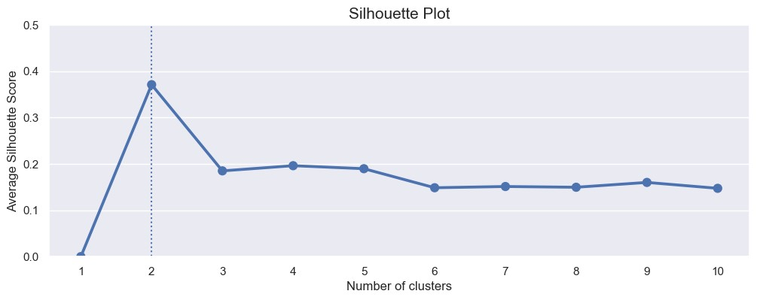

*Figure 2: Silhouette Plot*

From the above Silhouette Plot, we see that the silhouette score for 2 clusters is maximum. The Elbow method also suggested the optimal number of clusters as 2. Therefore, we choose optimal number of clusters as 2 and perform final segmentation using k equal to 2.

### Visualizing the Clusters using PCA

To visualize the clusters, Principal Component Analysis was used to reduce the dimensionality 2. The scatter plot with color coding using the 2 cluster labels is shown below. From the below figure we see that; both the clusters are well separated from each other. The yellow cluster has fewer data points than the purple cluster.

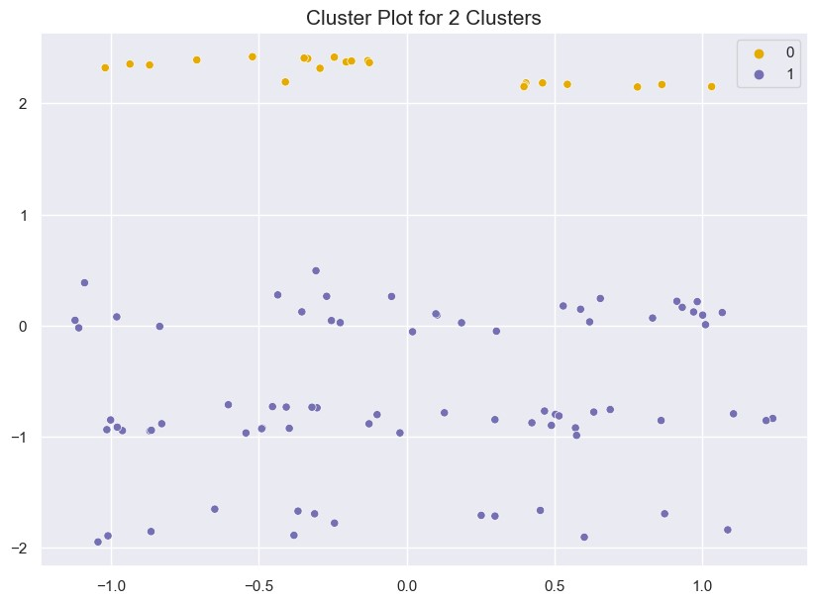

*Figure 3: Cluster Plot for 2 Clusters*

## Profiling the segments

In the below table, we summarize the 2 clusters using the variables in the dataset.

**Feature Cluster 1 Cluster 2**

|  |  |  |
| --- | --- | --- |
| **Average age** | 30 | 40 |
| **Most common profession** | Salaried | Salaried |
| **Marital status** | Single | Married |
| **Level of education** | Post Graduate | Post Graduate |
| **Average number of dependents** | 0 | 3 |
| **Loan type** | No loan | No loan |
| **Wife working status** | No | Yes |
| **Average salary** | 1300000 | 1900000 |
| **Average wife salary** | 300000 | 600000 |
| **Average total salary** | 1600000 | 2500000 |
| **Most popular make of car** | Baleno, Ciaz, Creata | SUV |

**Average price of car** 1100000 1200000

*Table 1: Segment Profiles*

The top 4 variables/features that can be used to create most optimal market segments for the Indian car market are:

* **Age**: The age of the car buyer is a good predictor of their needs and wants. Younger buyers are more likely to be looking for affordable cars, while older buyers are more likely to be looking for expensive cars.
* **Income**: The income of the car buyer is another good predictor of their needs and wants. Buyers with higher incomes are more likely to be able to afford expensive cars.
* **Education level**: The education level of the car buyer is also a good predictor of their needs and wants. Buyers with higher education levels are more likely to be looking for cars that are fuel-efficient and environmentally friendly.
* **Family size**: The family size of the car buyer is also a good predictor of their needs and wants. Buyers with larger families are more likely to be looking for cars that are spacious and comfortable.

These are just a few of the variables/features that can be used to create market segments for the Indian car market. By carefully considering these factors, car manufacturers can create products that meet the needs of different types of buyers.

## Conclusion

As you can see, the two clusters are quite different in terms of their demographics and purchase behaviour. Cluster 1 is made up of younger, less well-off professionals who are looking for affordable cars. Cluster 2 is made up of middle-aged, well-off professionals who are looking for expensive cars.

Here are some of the key differences between the two clusters:

* Age: The average age of the buyers in Cluster 1 is 30, while the average age of the buyers in Cluster 2 is 40. This suggests that Cluster 1 is made up of younger professionals, while Cluster 2 is made up of more experienced professionals.
* Income: The average total salary of the buyers in Cluster 1 is 1600000, while the average total salary of the buyers in Cluster 2 is 2500000. This suggests that Cluster 1 is made up of less well-off professionals, while Cluster 2 is made up of more well-off professionals.
* Car preference: The most popular make of car in Cluster 1 is Baleno, Ciaz, and Creata, which are all relatively affordable cars. The most popular make of car in Cluster 2 is SUV, which are typically more expensive cars.

These differences suggest that the two clusters are looking for different things in a car. Cluster 1 is looking for an affordable car that is reliable and fuel-efficient. Cluster 2 is looking for a more luxurious and powerful car that can accommodate their families.

# Marketing Mix

The ideal target segment for the EV startup entering the Indian market would consist of younger, less well-off professionals who are looking for affordable cars. This segment is the largest and fastest-growing segment in the Indian EV market. These buyers are more likely to be price-sensitive, so the EV startup should focus on offering an affordable EV that meets their needs.

The marketing mix for this segment would focus on the following elements:

* **Product**: The EV should be affordable, efficient, and stylish. It should also have a range that is suitable for the Indian driving conditions.
* **Price**: The price of the EV should be competitive with other EVs in the market. However, it should also be affordable for the average Indian consumer. The EV should be priced so that it is accessible to a wide range of potential buyers.
* **Place**: The EV should be available in a variety of dealerships across India. The dealerships should be located in urban and semi-urban areas where there is a demand for EVs. The dealerships should also be equipped with charging stations so that buyers can easily charge their EVs.
* **Promotion**: The EV should be promoted through a variety of channels, including online and offline marketing. Online marketing should be used to reach a wide audience. Offline marketing should be used to reach potential buyers in urban and semi-urban areas. The promotion should focus on the benefits of EVs, such as their environmental friendliness and affordability.
* **People**: The EV startup should hire a team of experienced professionals who are passionate about EVs. The team should be able to understand the Indian market and develop a marketing strategy that is effective in reaching potential buyers.
* **Process**: The EV startup should have a smooth and efficient sales process. The process should be easy for buyers to understand and follow. The startup should also provide excellent customer service to ensure that buyers are satisfied with their purchase.
* **Physical Evidence**: The EV startup should create a physical presence that is consistent with the brand. The dealerships should be well-designed and should reflect the company's commitment to quality. The EV itself should be well-designed and should meet the expectations of potential buyers.

This marketing mix would be effective in reaching the target segment and convincing them to purchase an EV. The EV startup would need to tailor the marketing message to the specific needs and interests of the target segment. For example, the marketing message could focus on the environmental benefits of EVs or the affordability of the EV.

The EV startup would also need to make sure that the EV is available in dealerships that are convenient for the target segment. The dealerships should be located in urban and semi-urban areas where the target segment lives and works. The dealerships should also be equipped with charging stations so that buyers can easily charge their EVs.

By following these marketing strategies, the EV startup would be well-positioned to succeed in the Indian EV market.

# Further Possible Improvement

Given additional time and budget, the market segmentation project can be improved in the following ways:

* Collect additional data points, such as the car buyers' satisfaction, ratings for different EV features, etc.
* Try additional ML models, such as the hierarchical clustering algorithm and the Gaussian mixture model.
* Conduct a more detailed analysis of the data, such as a chi-squared test or a discriminant analysis.